MTConnect Adapter for Haas

Setup Guide

Rev A (2/19/2020)

# Install

1. Download the installer from:

<http://apps.trakhound.com/app?id=2EE2D518-E9B0-C813-6E24-E39DA4203830>

1. Run the installer on the PC used as the MTConnect server

*Note: Adapters may be installed on the same server or on multiple depending on the architecture needed.*

1. Browse to “C:\Program Files (x86)\TrakHound\MTConnect Adapter for Haas\Adapter” and open the “config.xml” file. The file should look similar to the below:

<?xml version="1.0" encoding="utf-8" ?>

<Configuration>

  <Device>

    <!-- Device Name used in Devices.xml file for MTConnect® Agent's schema -->

    <DeviceName>Haas_Device</DeviceName>

    <!-- Port to communicate with MTConnect Agent -->

    <Port>7885</Port>

    <!-- Adapter heartbeat -->

    <Heartbeat>500</Heartbeat>

    <!-- COM Port to communicate with the Haas machine -->

    <EthernetServer>192.168.1.101</EthernetServer>

    <EthernetPort>5051</EthernetPort>

  </Device>

</Configuration>

1. Edit the DeviceName, Port, EthernetServer, and EthernetPort as necessary.

* DeviceName – Should match the Name in the “haas.xml” file in the “C:\Program Files (x86)\TrakHound\MTConnect Adapter for Haas\Agent\bin” directory
* Port – Should match the Port specified in the “agent.cfg” file for the specified adapter in the “C:\Program Files (x86)\TrakHound\MTConnect Adapter for Haas\Agent\bin” directory
* EthernetServer – Should match the IP address of the Haas machine
* EthernetProt – Should match the Port setup on the Haas machine for data output

1. Restart the Adapter service using either Task Manager or the Services window:

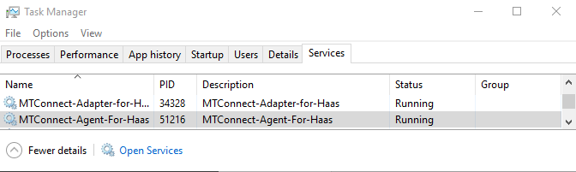

1. Open a web browser and browse to:

<http://localhost:5000/current>

This should show the current values from the Haas machine and should update with the browser’s Refresh (assuming the values on the Haas machine are actively changing)

# Adding Additional Devices

1. To add additional devices to the same server, browse to “C:\Program Files (x86)\TrakHound\MTConnect Adapter for Haas\Adapter” and open the “config.xml” file. Copy the Device node in the XMl and paste it below the current device(s) as shown below:

<?xml version="1.0" encoding="utf-8" ?>

<Configuration>

  <Device>

    <!-- Device Name used in Devices.xml file for MTConnect® Agent's schema -->

    <DeviceName>Haas_Device</DeviceName>

    <!-- Port to communicate with MTConnect Agent -->

    <Port>7885</Port>

    <!-- Adapter heartbeat -->

    <Heartbeat>500</Heartbeat>

    <!-- COM Port to communicate with the Haas machine -->

    <EthernetServer>192.168.1.101</EthernetServer>

    <EthernetPort>5051</EthernetPort>

  </Device>

  <Device>

    <!-- Device Name used in Devices.xml file for MTConnect® Agent's schema -->

    <DeviceName>Haas_Device_2</DeviceName>

    <!-- Port to communicate with MTConnect Agent -->

    <Port>7886</Port>

    <!-- Adapter heartbeat -->

    <Heartbeat>500</Heartbeat>

    <!-- COM Port to communicate with the Haas machine -->

    <EthernetServer>192.168.1.102</EthernetServer>

    <EthernetPort>5051</EthernetPort>

  </Device>

</Configuration>

1. Restart the Adapter service.
2. Browse to “C:\Program Files (x86)\TrakHound\MTConnect Adapter for Haas\Agent\bin” and open the “haas.xml” file in a text editor. Copy the Device Xml node and paste it below the current device(s). Be sure to edit the “id” of each Device, Component, and DataItem as they must be unique throughout the entire document (per XML standards).
3. Restart the Agent service.